Assignment0: Installing R/RStudio/LaTeX

You will need access to R/RStudio for this course. There are two options to get access:

1. Install R/RStudio locally on your computer
2. Access RStudio Cloud online

You can choose either option (or both). The instructions below provide details on both. Some students have had difficulty with running RStudio locally in the past and RStudio Cloud is a good alternative should this happen to you.

# Installing R/RStudio/Latex Locally

**R Installation**

* Go to <https://cran.csiro.au/>
* Download appropriate copy of R (Mac/Windows/Linux)
* Open downloaded file and follow installation instructions

**R Studio Installation**

* Go to <https://www.rstudio.com/products/rstudio/download/#download>
* Open downloaded file and follow installation instructions

**LaTeX Installation**

If you are using Windows, install MiKTeX:

* Go to <https://miktex.org/download>
* Open downloaded file and follow installation instructions
  + NOTE: When installing MiKTeX, be sure to select the option to “Install Missing Packages” that may come up in one of the prompts

If you are using a Mac, install MacTeX:

* Go to <http://www.tug.org/mactex/>
* Open downloaded file and follow installation instructions

**Setting up RStudio**

* Open RStudio
* Open an R script (using the + button on the top left, select “R Script”)

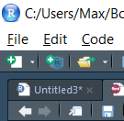

* Enter the following code in the script box below (see image below)
  + install.packages("tidyverse")
  + install.packages("rmarkdown")

A screenshot of a computer screen

Description generated with very high confidence

* Press control+enter after each line and wait for packages to install
* Create a new RMarkdown document (see image below)

**A screenshot of a computer screen

Description generated with very high confidence**

* + Install any additional packages if asked
* You should get to a prompt similar to below
* Select “PDF” (middle option) and click “OK” at the bottom right of the prompt

**A screenshot of a computer screen

Description generated with very high confidence**

* **Be sure to replace your name in the “author” field**
* Click “Knit” (the blue ball of yarn towards the top as depicted below)

**A screenshot of a computer screen

Description generated with very high confidence**

* This should produce a PDF (see below)
  + If you have any errors come up, try using Google to figure out what went wrong

**A screenshot of a computer

Description generated with very high confidence**

* Submit the PDF through Canvas for Assignment0 (see below)
* If you were unable to produce the PDF, please come to office hours or post to the discussion board!



# Accessing RStudio via RStudio Cloud

1. Go to RStudio.cloud
2. Click “Sign Up” in right-hand corner
3. Select “Cloud Free” and click “Sign Up”
4. Create Username and Password (or sign up via existing Google/GitHub accounts)
5. After creating your account, the homepage should look like below:

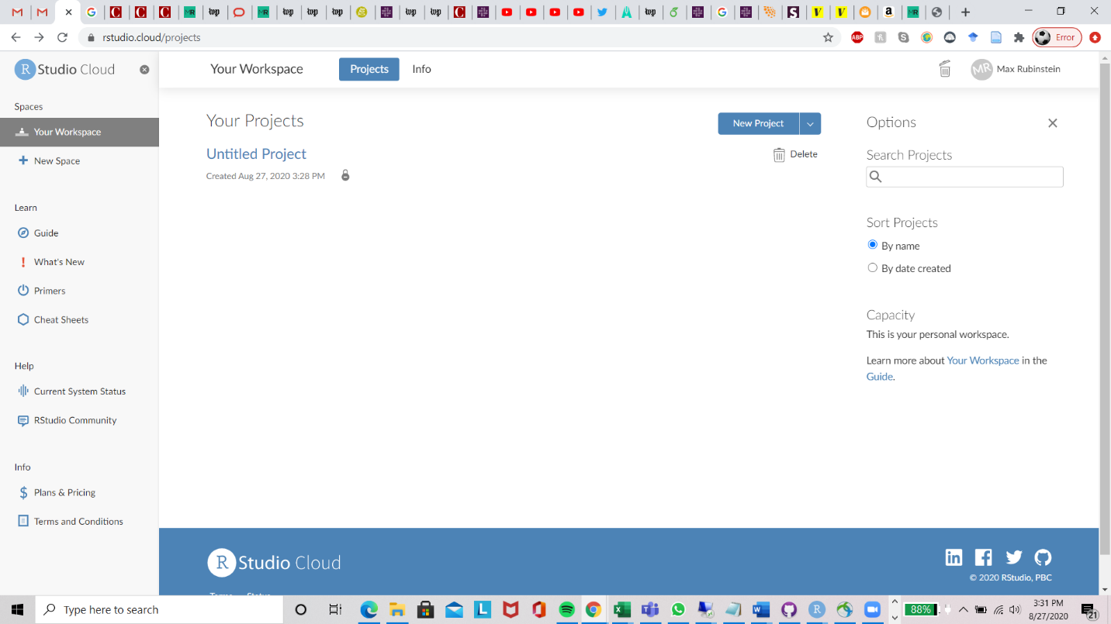

1. Click “New Project” to start a new workspace and to open up a window where you can now use RStudio
2. Follow the steps beginning with the second bullet under **Setting up RStudio** at the bottom of Page 1 of this document. Follow those steps through creating a PDF and submitting it though Canvas (Page 5 of this document).
   1. We recommend that you export the file and save to locally to your laptop in case you are unable to find files in the cloud later